**IMDB DATASET ANALYSIS**

**-ADVANCED** SQL PROJECT

**JOTHEESWARAN S**

**28/03/2025**

**DATA ANALYTICS & DATA SCIENCE**

**FEB 25’**

DATASETDESCRIPTION**:**

* The dataset provided is a simplified version of the IMDb database, structured to capture essential information about movies, their genres, actors, directors, ratings, and more.

AVAILABLEINFORMATION**:**

1. Movie: (7997 records)
2. Genre: (14662 records)
3. Director Mapping: (3867 records)
4. Role Mapping: (151615 records)
5. Names :(25735 records)
6. Ratings: (7997 records)

DATA DESCRIPTION:

* **Movie**:

Contains basic information about each movie, including title, release year, duration, country, income, languages, and production companies.

* **Genre**:

Describes the genres associated with each movie.

* **Director Mapping**:

Maps movies to their directors.

* **Role Mapping**:

Maps actors/actresses to movies and specifies the role category

* **Names**:

Stores information about people including their birthdates, heights, and known movies.

* **Ratings**:

Contains ratings information for movies, including the average rating, total votes, and median rating.

QURIES AND OUTPUTS

1. Count the total number of records in each table of the database.

select count(*) as count_of_directormapping from director_mapping;

select count(*) as count_of_genre from genre;

select count(*) as count_of_movie from movie;

select count(*) as count_of_names from names;

select count(*) as count_of_ratings from ratings;

select count(*) as count_of_rolemapping from role_mapping;



2. Identify which columns in the movie table contain null values

SELECT

CASE WHEN COUNT(*) - COUNT(title) > 0 THEN 'title has nulls'

ELSE'title has no nulls'

END AS title,

CASE WHEN COUNT(*) - COUNT(year) > 0 THEN 'year has nulls'

ELSE'year has no nulls'

END AS year,

CASE WHEN COUNT(*) - COUNT(duration) > 0 THEN 'duration has nulls'

ELSE'duration has no nulls'

END AS duration,

CASE WHEN COUNT(*) - COUNT(country) > 0 THEN 'country has nulls'

ELSE'country has no nulls'

END AS country,

CASE WHEN COUNT(*) - COUNT(worlwide_gross_income) > 0 THEN 'worlwide_gross_income has nulls'

ELSE'worlwide_gross_income has no nulls'

END AS worlwide_gross_income,

CASE WHEN COUNT(*) - COUNT(date_published) > 0 THEN 'date_published has nulls'

ELSE'date_published has no nulls'

END AS date_published,

CASE WHEN COUNT(*) - COUNT(languages) > 0 THEN 'languages has nulls'

ELSE'languages has no nulls'

END AS languages,

CASE WHEN COUNT(*) - COUNT(production_company) > 0 THEN 'production_company has nulls'

ELSE'production_company has no nulls'

END AS production_company

FROM movie;



3. Determine the total number of movies released each year, and analyze how the trend changes month-wise.

SELECT

release_year,

total_movies,

RANK() OVER (ORDER BY total_movies DESC) AS ranking

FROM (

SELECT

YEAR(date_published) AS release_year,

COUNT(title) AS total_movies

FROM

movie

GROUP BY

YEAR(date_published)

) AS subquery

ORDER BY total_movies DESC;

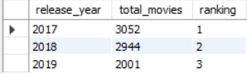

SELECT

RANK() OVER (ORDER BY total_movies DESC) AS ranking,

ELT(release_month, 'January', 'February', 'March', 'April', 'May', 'June',

'July', 'August', 'September', 'October', 'November', 'December') AS release_month_name,

release_month,

total_movies

FROM (

SELECT

MONTH(date_published) AS release_month,

COUNT(title) AS total_movies

FROM

movie

GROUP BY

MONTH(date_published)

) AS subquery

ORDER BY

total_movies DESC;

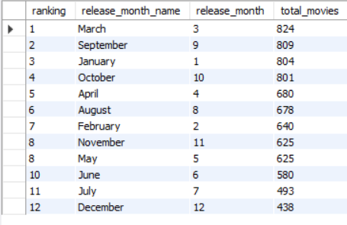

4. How many movies were produced in either the USA or India in the year 2019?

SELECT COUNT(title) AS number_of_movies_in_usa_or_india_from_2019

FROM movie

where (country="USA" OR country="INDIA") AND (YEAR="2019");



5. List the unique genres in the dataset, and count how many movies belong exclusively to one genre.

SELECT RANK()OVER(ORDER BY COUNT(movie_id) DESC) AS ranking,COUNT(movie_id) AS no_movie,genre

FROM genre GROUP BY genre ORDER BY

COUNT(movie_id) DESC;

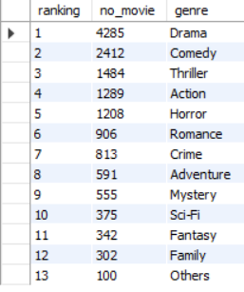

6. Which genre has the highest total number of movies produced?

SELECT genre,COUNT(movie_id) AS no_movie

FROM genre

GROUP BY genre

ORDER BY COUNT(movie_id) DESC LIMIT 1;



7. Calculate the average movie duration for each genre.

SELECT RANK()OVER(ORDER BY AVG(m.duration) DESC)AS ranking,g.genre,AVG(m.duration) FROM

genre g INNER JOIN movie m ON

g.movie_id=m.id GROUP BY genre;

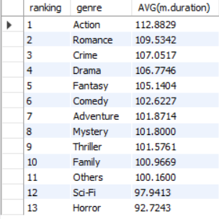

8. Identify actors or actresses who have appeared in more than three movies with an average rating below 5.

SELECT

m.id,

COUNT(m.title) AS movie_count,

AVG(rs.median_rating) AS avg_ratings

FROM movie m

INNER JOIN ratings rs ON m.id = rs.movie_id

GROUP BY m.id

HAVING COUNT(m.title) > 3 AND AVG(rs.median_rating) < 5;

NO OUTPUT



9. Find the minimum and maximum values for each column in the ratings table, excluding the movie_id column.

SELECT MAX(avg_rating) AS max_averagerating,MIN(avg_rating) AS min_averagerating,

MAX(total_votes) AS maxvotes,MIN(total_votes) AS minvotes,

MAX(median_rating) AS max_medianrating,MIN(median_rating) AS min_medianrating

FROM ratings;



10. Which are the top 10 movies based on their average rating?

SELECT RANK()OVER (ORDER BY r.avg_rating DESC)AS ranking,m.title,r.avg_rating

FROM movie m inner join ratings r

ON m.id=r.movie_id GROUP BY m.title,m.id

ORDER BY avg_rating DESC LIMIT 10;

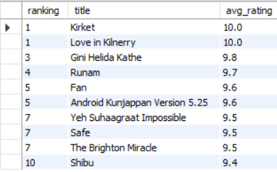

11. Summarize the ratings table by grouping movies based on their median ratings.

SELECT m.title,r.total_votes,r.median_rating

FROM movie m INNER JOIN ratings r

ON m.id=r.movie_id GROUP BY r.movie_id

ORDER BY median_rating ASC;

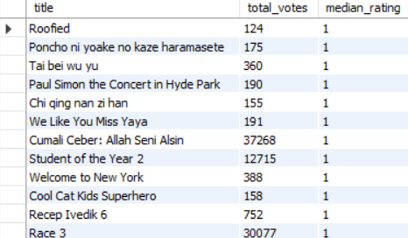

12. How many movies, released in March 2017 in the USA within a specific genre, had more than 1,000 votes?

SELECT COUNT(m.title),m.year,m.country,g.genre

FROM movie m INNER JOIN genre g

ON m.id=g.movie_id

INNER JOIN ratings r

ON r.movie_id=m.id

WHERE year="2017" AND country="usa" AND genre="romance"AND total_votes>"1000"

GROUP BY

m.year, m.country, g.genre;



13. Find movies from each genre that begin with the word “The” and have an average rating greater than 8.

SELECT g.genre,m.title,r.avg_rating

FROM movie m INNER JOIN genre g ON

m.id=g.movie_id

INNER JOIN ratings r

ON r.movie_id=m.id

HAVING title LIKE"the%" AND avg_rating>"8";

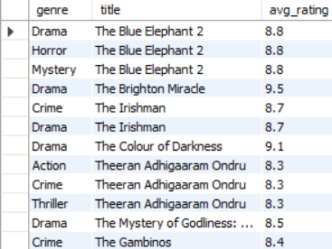

14. Of the movies released between April 1, 2018, and April 1, 2019, how many received a median rating of 8?

SELECT COUNT(m.title) AS number_movies_relesed_in_from_18to19,r.median_rating

FROM movie m INNER JOIN ratings r ON

m.id=r.movie_id

WHERE median_rating="8" AND (date_published >= '2018-04-01'

AND date_published< '2019-04-01');



15. Do German movies receive more votes on average than Italian movies?

SELECT

CASE

WHEN (

SELECT SUM(r.total_votes)

FROM movie m

INNER JOIN ratings r ON m.id = r.movie_id

WHERE m.country = "germany"

) > (

SELECT SUM(r.total_votes)

FROM movie m

INNER JOIN ratings r ON m.id = r.movie_id

WHERE m.country = "italy"

) THEN "GERMANY HAS HIGHEST TOTAL"

ELSE "ITALY HAS HIGHEST TOTAL"

END AS RESULT;



16. Identify the columns in the names table that contain null values.

SELECT

CASE WHEN COUNT(*) - COUNT(id) > 0 THEN 'id has nulls'

ELSE 'id has no nulls'

END AS id,

CASE WHEN COUNT(*) - COUNT(name) > 0 THEN 'name has nulls'

ELSE 'name has no nulls'

END AS name,

CASE WHEN COUNT(*) - COUNT(height) > 0 THEN 'height has nulls'

ELSE 'height has no nulls'

END AS height,

CASE WHEN COUNT(*) - COUNT(date_of_birth) > 0 THEN 'D_O_B has nulls'

ELSE 'D_O_B has no nulls'

END AS D_0_B,

CASE WHEN COUNT(*) - COUNT(known_for_movies ) > 0 THEN 'K_F_M has nulls'

ELSE 'K_F_M has no nulls'

END AS K_F_M

FROM names;



17. Who are the top two actors whose movies have a median rating of 8 or higher?

SELECT

n.name,rm.category,m.title,r.median_rating

FROM

ratings r

INNER JOIN movie m ON m.id = r.movie_id

INNER JOIN role_mapping rm

ON m.id = rm.movie_id

INNER JOIN names n ON rm.name_id = n.id

WHERE

r.median_rating >= 8 ORDER BY median_rating DESC LIMIT 5;

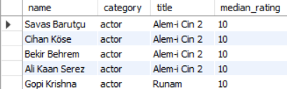

18. Which are the top three production companies based on the total number of votes their movies received?

SELECT m.production_company,m.title,r.total_votes

FROM movie m INNER JOIN ratings r

ON m.id=r.movie_id ORDER BY total_votes DESC LIMIT 3;

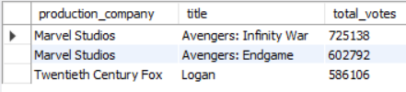

19. How many directors have worked on more than three movies?

SELECT d.name_id,COUNT(m.title)

FROM movie m INNER JOIN director_mapping d

ON m.id=d.movie_id GROUP BY d.name_id HAVING COUNT(m.title)>3 ORDER BY COUNT(m.title) DESC;

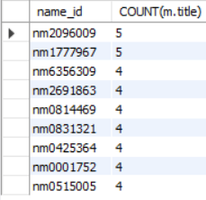

20. Calculate the average height of actors and actresses separately.

SELECT rm.category,AVG(n.height) AS average_height

FROM names n INNER JOIN role_mapping rm

ON n.id=rm.name_id GROUP BY category ORDER BY AVG(n.height) DESC;

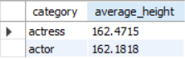

21. List the 10 oldest movies in the dataset along with their title, country, and director.

SELECT m.title,m.country,d.name_id AS director_id,m.year

FROM movie m INNER JOIN director_mapping d

ON m.id=d.movie_id ORDER BY year ASC LIMIT 10;

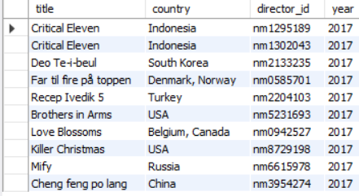

22. List the top 5 movies with the highest total votes, along with their genres.

SELECT DENSE_RANK()OVER(ORDER BY total_votes DESC) AS ranking,m.title,g.genre,r.total_votes AS votes

FROM movie m INNER JOIN ratings r

ON m.id=r.movie_id INNER JOIN genre g

ON m.id=g.movie_id ORDER BY total_votes DESC LIMIT 5;

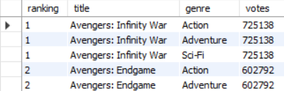

23. Identify the movie with the longest duration, along with its genre and production company.

SELECT m.title,m.duration,m.production_company,g.genre

FROM movie m INNER JOIN genre g

ON m.id=g.movie_id ORDER BY duration DESC LIMIT 4;

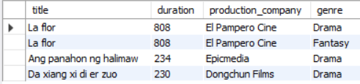

24. Determine the total number of votes for each movie released in 2018.

SELECT m.title,m.year,r.total_votes

FROM movie m INNER JOIN ratings r

ON m.id=r.movie_id WHERE year="2018" ORDER BY total_votes DESC;

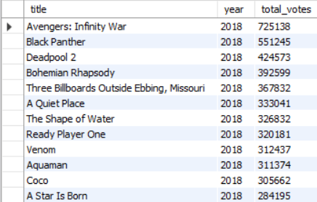

25. What is the most common language in which movies were produced?

SELECT DENSE_RANK()OVER (ORDER BY COUNT(title) DESC) AS rabking,COUNT(title) AS number_of_movies,languages FROM movie

GROUP BY languages ORDER BY COUNT(TITLE) DESC LIMIT 5;

